Template Final Narrative Report

Project Title: UN Regular Process Clearing House mechanism

Target Country or Region: Global

Budget code : 513GLO2028

Contract number : 450016976

Funding sources : Flanders

Total Budget approved: 19,426 USD

Reporting Period : January-June 2012

Executing Agency : IOC

Implementing partners : UNEP/GRID-ARENDAL

Project starting date: January 2012

Project completion date : June 2012

Responsible Sector : SC/IOC

Name of Person completing Report: J. Barbiere

- Summary and Background

The project activities included:
1. Undertake the development of a web-based clearing house mechanism, in close cooperation with the UN Group of Experts, in order to produce appropriate design specifications for a document management system, and in accordance with the specifications adopted by the UN Ad Hoc Working group (Annex IV of the Recommendations of the Ad Hoc Working group of the Whole to the sixty-sixth session of the UN general Assembly, June 2011).
2. Produce the overall web design and commence construction of front page
3. Purchase annual license for use of web based editorial management system
4. Develop the system and conduct trials and testing of the system, taking into account feedback received from the Group of Experts

- Description of project activities undertaken during the contract period

1. UNEP/GRID-Arendal engaged with members of the Group of Experts (GoEs) of the Regular Process to produce design specifications for a document management system and develop the system. The structure of the website was agreed with the GoEs.
GRID Arendal, working with Dr Peter Harris from the GOEs, developed and uploaded the content to the draft website (No’s 1-6 in Figure 1 below).

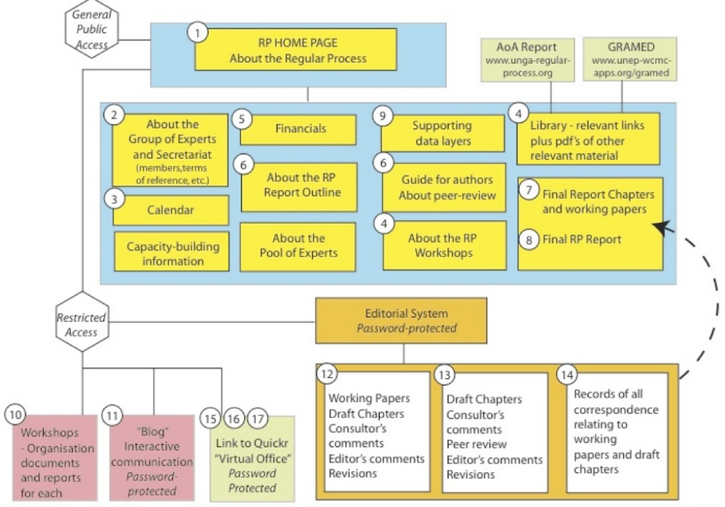

2. The website design (front page example Figure 2 below) was presented to the GOEs at the meeting in New York in April 2012. The GOEs were provided with a reviewer’s checklist to provide comments and feedback. The results of this evaluation are currently being incorporated into the final product.

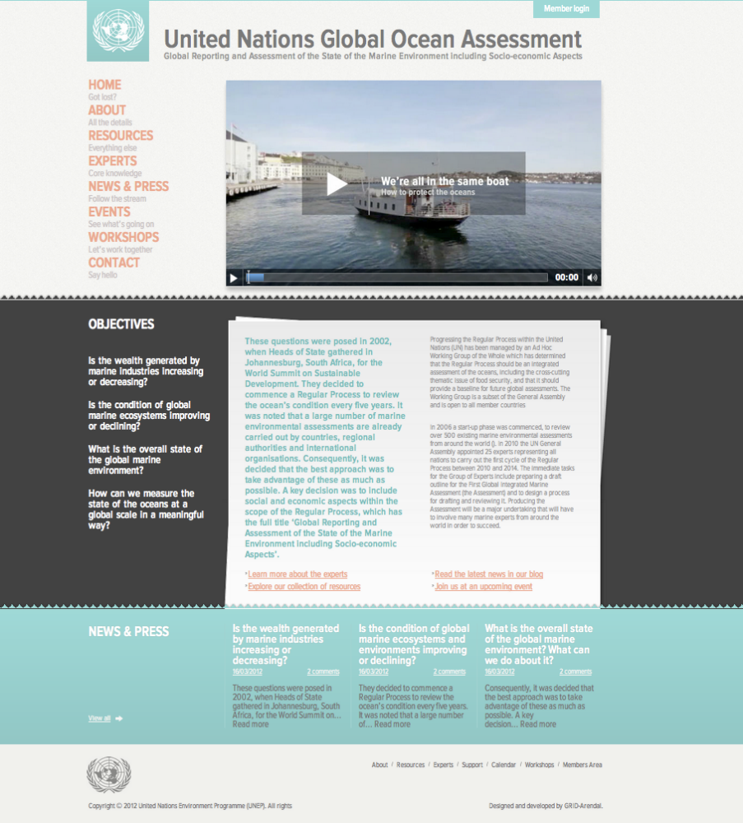

3. An annual license for Editorial Manager (Aries) was purchased and GRID Arendal worked with Editorial Manager staff to configure the software to support the requirements of the Regular Process Reporting (No’s 12-14 in Figure 1).

4. A number of staff at GRID Arendal, Dr Peter Harris and Dr Alan Simcock received training in the use of the Editorial Manager system. Additional training will be offered to the GOEs when the reporting for the Regular Process begins.

- Difficulties and Problems encountered and measures taken, changes in implementation.
No specific problem have been encountered

- Project Results achieved and indicators in accordance with the log frame (please also complete the attached matrix table)

The Project result which is to lay the foundation for the RP Clearing House mechanism has been achieved. More funds will need to be raised in order to construct the different component of the Web Site.

- Visibility:

The contribution of IOC and Flanders will appear in on web site.

