Project title: | SPINCAM - Southeast Pacific Data and Information Network in Support to Integrated Coastal Area Management
Target Country or Region: | Southeast Pacific Region: Chile, Colombia, Ecuador, Panama and Peru.
Budget code: | 513RLA2013
Funded sources: | UNESCO Flanders Science Trustfund
Total Budget approved: | 880.000 USD (2013-2015)
Reporting period: | December 2012 – September 2013
Executing Agency: | IOC-UNESCO
Implementing partners; | CPPS and member states
Project starting date: | 1 December 2012
Project completion date: | 31 December 2015
Responsible sector: | IOC/OSS
Name of Person completing the report: | Julian Barbière  Alejandro Iglesias-Campos

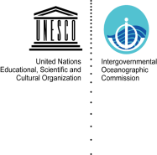
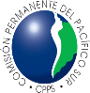
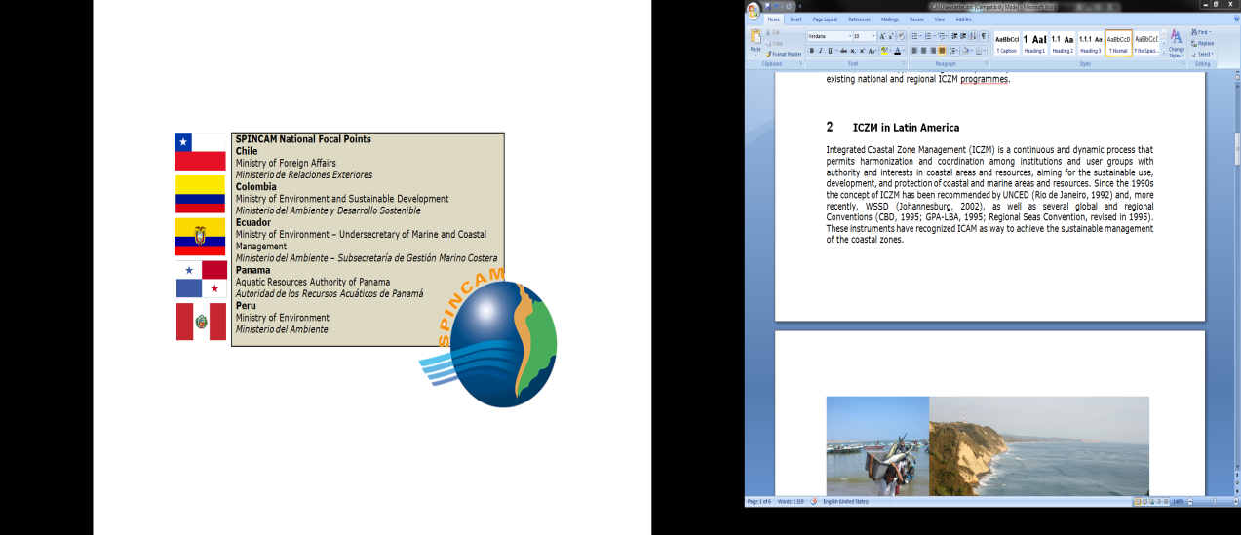
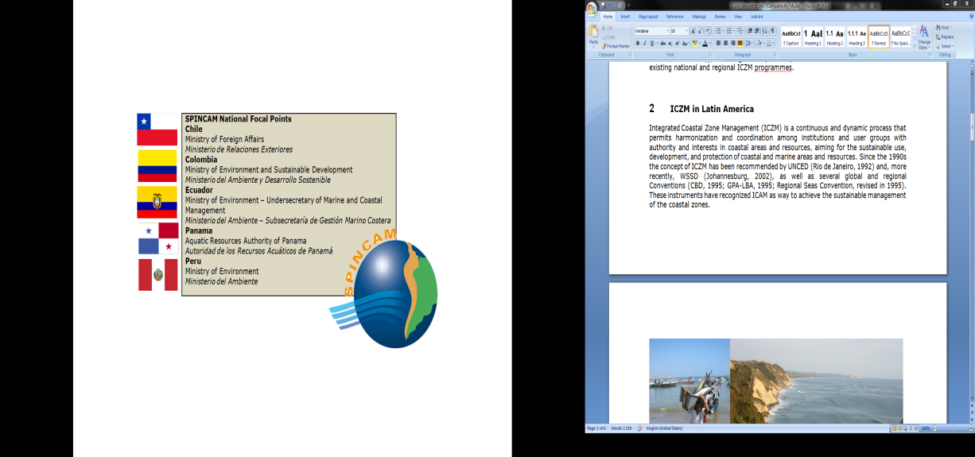
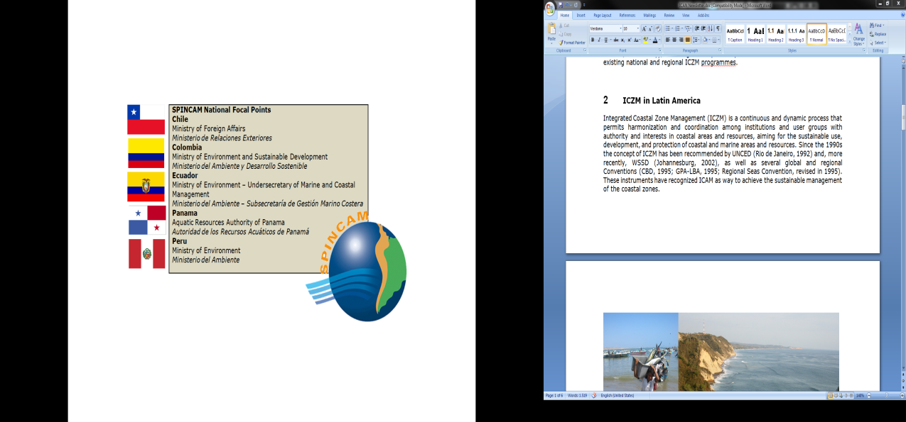
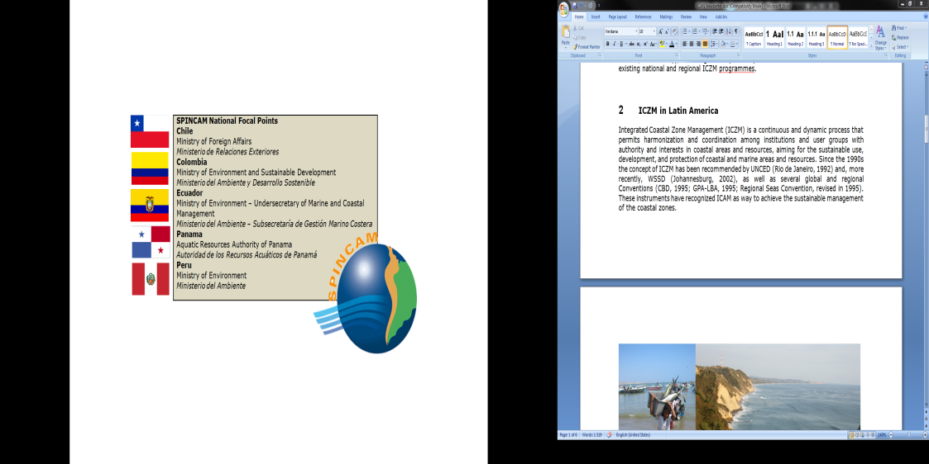
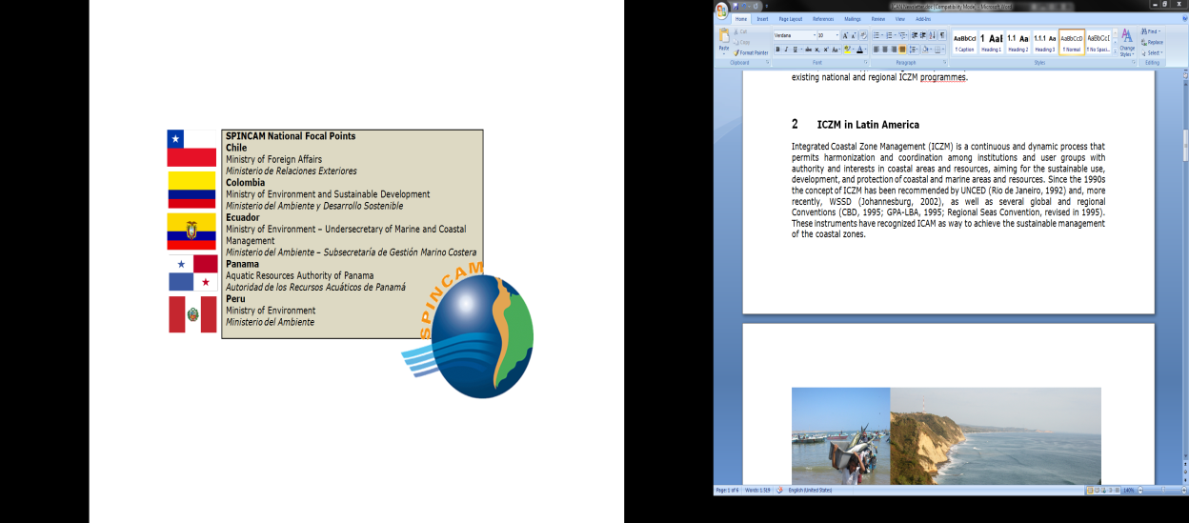




- Summary and Background (1 page)

The SPINCAM project “Southeast Pacific data and information network in support to integrated coastal area management” funded by the Flemish Government of Belgium was approved in 2008, and its second phase in 2012, has been developed since 2009 under the coordination of IOC-UNESCO and the Permanent Commission for the South Pacific, CPPS. SPINCAM was designed to establish an integrated coastal area management (ICAM) indicator framework at national and regional level in the countries of the Southeast Pacific region (Chile, Colombia, Ecuador, Panama and Peru) focusing on the state of the coastal and marine environment and socio-economic conditions, to provide stakeholders with information on the sustainability of existing and future coastal management practices and development.

During the first phase of SPINCAM (2009-2012), the project has focused on the development of harmonized methodology to design sets of national indicators and to reach an agreement between the five countries to design a core set of common regional indicators. One of the goals of SPINCAM is to build up information systems, first to help the development of indicators and second to disseminate the results through coastal and marine web atlases both at national and regional level.

At the end of the first phase, national reports showed the work progress and the level of accomplishment of objectives per country. These reports identified the unbalances amongst countries in terms of technical capacity to reach the agreed objectives, such as the development of national indicators and the establishment of the basis for a national web atlas. Colombia was the only participant country that developed the planned national web atlas.

- Description of project activities undertaken during the reporting period

Code | Activity | Month
WP1 – Project management and coordination
A1 | Establishment of project coordination and monitoring mechanism at regional level | Dec 2012  June 2013
A2 | Establishment of Partnership Agreement between global (IOC) and regional (CPPS) coordinator. | June 2013
A3 | Establishment of administrative, financial and reporting procedures | In process
A4 | Organization of inception meeting in Santiago de Chile, CL | Dec 2012
A5 | Organization of Steering Committee:  - The next Steering Committee will take place in Santa Marta, CO in December 2013. | Jul – Dec 2013
A7 | Present project at various forums and disseminate information:  - Presentation and poster of SPINCAM in ICAN and CoastGIS2013 Conference, Victoria Canada, June 2013  - Update of website contents and improvement of communication skills.  - SPINCAM in the ICAN Newsletters | June – Sep 2013
WP2 – ICAM Indicators platform
C1 | Consultation (survey) with SPINCAM stakeholders and users to identify ICAM needs, expected SPINCAM II data and information products, including new indicators | June – Sept 2013
E1 | Identification and development of additional regional indicators to be included in the Regional Atlas:  - Technical workshop will take place in Santa Marta, CO in December 2013. | Started in July 2013
F3 | Identification of additional local data sources | Started in June 2013
WP3 – Data and information systems
H2 | Assessment of technological and human capacity requirements for data and information:  - Survey distributed to all national institutions involved in SPINCAM | June-Sept 2013
J1 | Acquiring and processing of suitable datasets for processing, including geographic scope and scape:  - Agreement with the University of Duke to access spatial information on marine and coastal parameters and indexes | Sept 2013
J3 | Further development of national and regional atlases:  - Training materials available in BaseCamp for national technical staff in charge of developing the national atlases.  - Software migration to Smart Atlas to improve the Regional Atlas. | June-Sept 2013.
WP4 – Communication
L1 | Design and conduct of a stakeholder survey to measure awareness (or lack of) with regards to ICAM, and data/information in support of decision making, as well as perceived needs:  - Survey distributed to all national institutions involved in SPINCAM | June-Sept 2013
Code | Activity | Month
M5 | Participation of project representatives in international networks:  - SPINCAM – CPPS Project Coordinator as member of ICAN Steering Committee for Latin America  - IOC-UNESCO – ICAM, member of ICAN Steering Committee  - SPINCAM National representatives as members of IBERMAR Coastal Network | 2013
WP5 – Capacity building
N1 | Identification of national institutional actors and training needs, both technical (data/info management) and ICAM :  - Survey distributed to all national institutions involved in SPINCAM | June-Sept 2013
O1 | National training courses:  - GIS training of 5 national experts and CPPS at the International University of Andalusia, ES | April-June 2013
O3 | Regional training workshops (with the support of ODINCARSA and ICAM), including train-the trainer activities:  - Ocean Data Portal, 15-16 October, Buenos Aires, AR  - Data publishing, December 2013, Santa Marta, CO  - Atlas development, December 2013, Santa Marta, CO  - E-Repository, expected for January 2014, Guayaquil, EC | Continuous process
O4 | Cooperation activities with academic institutions/other projects:  - Cooperation with the International University of Andalusia, ES  - Cooperation with the University of Cartagena, CO  - Cooperation with ESPOL Guayaquil, EC  - Cooperation with the University of Duke, US  - Cooperation with the Caribbean Marine Atlas (FUST Project)  - Participation of SPINCAM and IOC in the CMA Meeting that will take place in December 2013 in Miami, US  - Cooperation with the African Marine Atlas (FUST Project)  - Exchange of lessons learnt and future collaboration opportunities, October 2013, Brussels, BE  - Cooperation with the Caribbean LME (FUST Project)  - Cooperation with PEGASO (FP7 Project)  - SPINCAM countries as end users of PEGASO products: indicators, governance platform, et al.  - SPINCAM to participate in the final conference of PEGASO that will take place in January 2014 in Turkey. | Continuous process

- Difficulties and Problems encountered and measures taken, any changes in implementation.

During the reporting period, some interaction problems with participant countries have been identified. The internal hierarchy and the diverse administrative structure are contributing to delay all the administrative processes needed for the establishment of the collaboration agreement in between CPPS and the national institutions.

The duplication of responsibilities in between the CPPS National Representatives, normally represented by Ministries of Foreign Affairs, and the National Focal Points of SPINCAM, represented by Ministries of Environment and Research Institutes, require additional coordination efforts and time to find common consensus on specific requests, such as the technical or administrative surveys, but also for the crucial signature of the administrative agreement with CPPS.

These problems create limitations and difficulties to advance with the project implementation and certainly affect the agreed work plan.

- Project Results achieved during the reporting period

During this reporting period, the following results have been achieved:

- Improvement of GIS and atlas development technical capacities of national and CPPS experts
- Identification of national focal points and experts that will be involved during the project implementation.
- Improvement of the project visibility at international level and in international networks, as well as the support of the Government of Flanders.
- Better interaction in between SPINCAM, IODE and ODINCARSA.
- Interaction with other projects funded by FUST, such as the Caribbean and African Marine Atlases and the Caribbean Large Marine Ecosystem.

- Lessons learned and Sustainability

The identification of key experts involved in SPINCAM at national level will facilitate the training to those experts who have shown interest and their compromise to support the implementation of this second phase of SPINCAM.

IOC-UNESCO aims member countries to integrate the SPINCAM Project objectives into their national work planning, in order to ensure the sustainability and use of the project results and its dissemination after the project life.

Evaluation recommendations when applicable

FUST external expert evaluators, Savithri Narayanan and Wouter Buytaert, visited CPPS, well Ecuador and Colombia in April 15 to 19, 2013.

The FUST Official evaluation report in 2013 recommended enhancing the usefulness of the coastal indicators at national, municipal and provincial levels by enabling the SPINCAM team to make the results available through various media including social networks, and through publications such as the State of the Coast reports.

In this sense, the work package 2 considers the expansion of regional indicators frameworks by identifying and developing additional regional indicators to be included in regional atlases, and to organize regional workshops on these topics.

Additionally, the project will identify local authorities and municipalities where SPINCAM approach can be implemented. A pilot case study per country will be developed by including consultation with local stakeholders and technical partners.

This consultation will help the identification of additional local data sources, and the preparation of local methodological sheets, as well as the calculation of indicators, by integrating local indicator results within SPINCAM national atlases and products.

- Visibility: describe any visibility action implemented during the reporting period


SPINCAM project has been presented in different international conferences related to spatial information, coastal and marine management and planning and development of coastal and marine web atlases.

The support of the Government of Flanders is well promoted by including in all documents and presentations the official logos in Spanish and English with the legend “With the support of the Flemish Government”.

- Work plan for the following period (Please see attached table in Annex I)

- Publications , reports and other project outputs (Please see web links in Annex II)

Annex I - SPINCAM Annual Workplan (Main activities)

Project Code: 513RLA2013
Title: SPINCAM Southeast Pacific Data and Information Network in Support to Integrated Coastal Area Management.
Year : 2013

Planned Activities | Expected Outputs | Timeframe  From To |  | Responsible
Establishment of administrative, financial and reporting procedures with national SPINCAM agencies | Agreed work plan and clear involvement of national experts in the project | NOV2013 | END OF THE PROJECT | IOC/CPPS  Countries
Continue presenting the project at regional and international level | Improve the visibility of the project and the support of the Government of Flanders | OCT2013 | END OF THE PROJECT | IOC/CPPS  Countries
Establishment of inter-institutional agreements between National Focal Points and National Ocean Data Centers | Improve the interaction with relevant institutions and share of good practices in terms of data management and visualization. | OCT2013 | MAR2014 | Countries
Present project objectives at national level and disseminate information of the project o various stakeholders | Improve the visibility of the project and the involvement of other national institutions in development of the project at national level. | JAN2014 | END OF THE PROJECT | Countries
Regional workshop on indicators, validation and its implementation at national and local level. | Development of new indicators at national and regional level by following a common methodology and its potential implemententation at national and local level. | DEC2013 | DEC2014 | Countries
Integration of national and regional indicators in national and regional atlas | Improve the spatial data and contents of the SPINCAM regional atlas. | JUN2014 | END OF THE PROJECT | IOC/CPPS  Countries
Identification of local authorities and pilot case studies to implement SPINCAM approach. Compilation and use of new local data sources. | Test SPINCAM approach (indicators et al.) at different scales from local to regional level. | JUN2014 | END OF THE PROJECT | Countries
Studying and implementing interoperability framework for regional data system, based on ODP v2. | Improve shared environmental information systems and integrate additional data sources in the regional atlas | FEB2014 | JUN2014 | IOC/CPPS  Countries
Prepare national e-repository | Improve the compilation of relevant ICAM information documentation by using OceanDocs and IODE capacity, as well as the interaction with national e-repositories | MAR2014 | END OF THE PROJECT | IOC/CPPS  Countries
Implementation of the SPINCAM communication strategy and development of specific communication materials at national, regional and international level. Update the SPINCAM website, contents and functionalities. | Improve the project visibility, as well as the Flemish government support | JAN2014 | JUN2014 | IOC/CPPS  Countries  Government of Flanders
Regional training workshops and cooperation with other projects funded by FUST | Improve training capacities and share of lessons learnt from other projects | OCT2013 | END OF THE PROJECT | IOC/CPPS  Countries

Annex II - Publications , reports and other project outputs

- SPINCAM Website

http://www.spincamnet.net/

- Presentations and atlases at the ICAN and Coast GIS Conferences in Victoria, Canadá.

http://ican.science.oregonstate.edu/es/ican6_prog_es

