ANNEX 2: LETTERS OF EXPRESSION OF INTEREST AND COUNTERPART CONTRIBUTIONS

Part 1: RTC CANDIDATES

RTC Candidate 1: Indian National Centre for Ocean Information Services (INCOIS)
Ministry of Earth Sciences, Government of Indian
“Ocean Valley”, Pragathi Nagar BO, Nizampet SO
Hyderabad – 500 090 - INDIA

Date of Letter: 23 August 2013

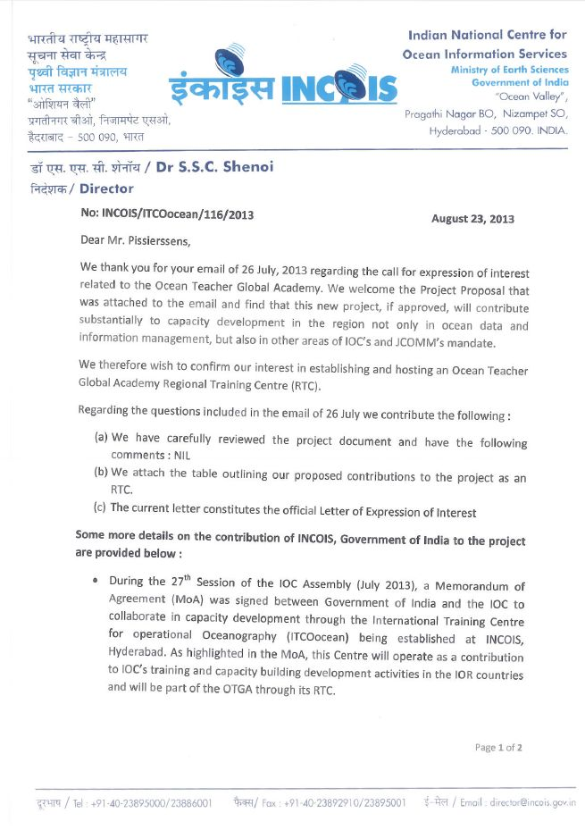

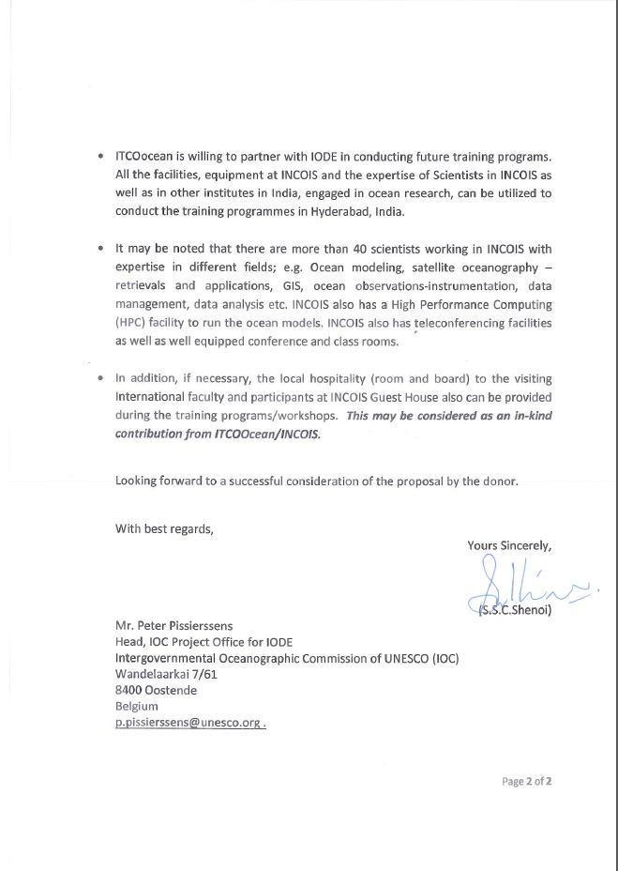

RTC Candidate 2: Universiti Malaysia Terrengganu
Pejabat Timbalan Naib Canselor (Akademik & Antarabangsa)
21030 Kuala Terengganu
Terengganu - MALAYSIA

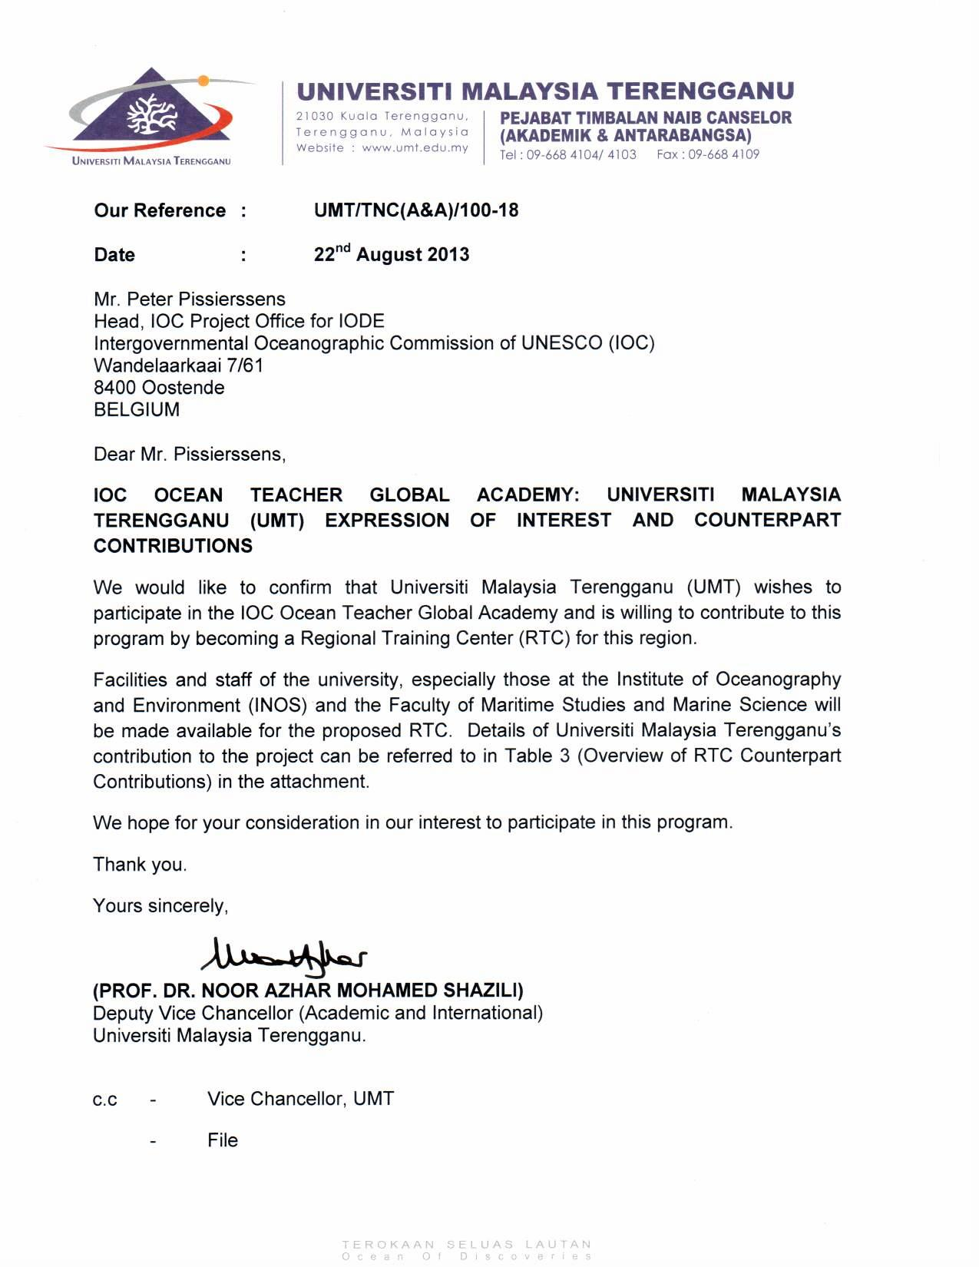

RTC Candidate 3: African Centre for Ocean Governance (AfriCOG)
18 Somerset Street, Private Bag 1015
Grahamstown, 6140 - South Africa
Contact: David Vousden, CEO AfriCOG and
Regional Director, Agulhas and Somali Current LME Project
Email: david.vousden@asclme.org or info@africog.net

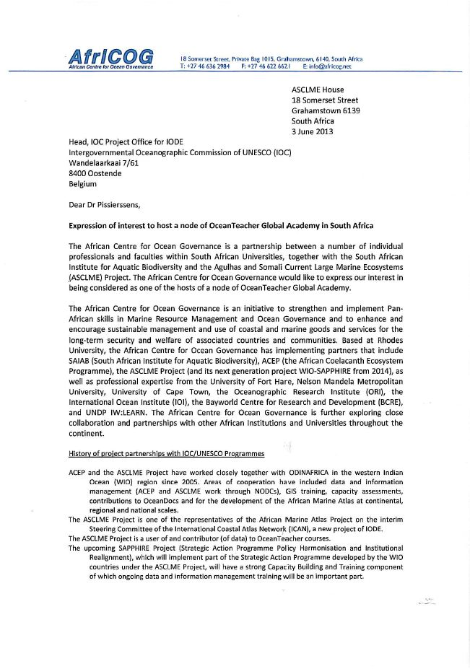
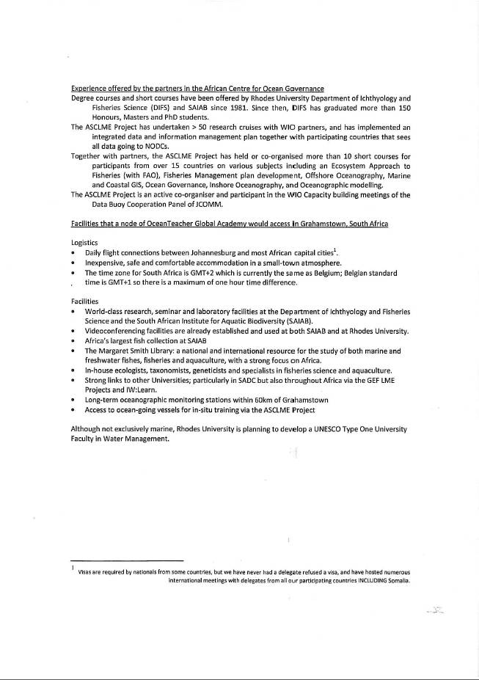

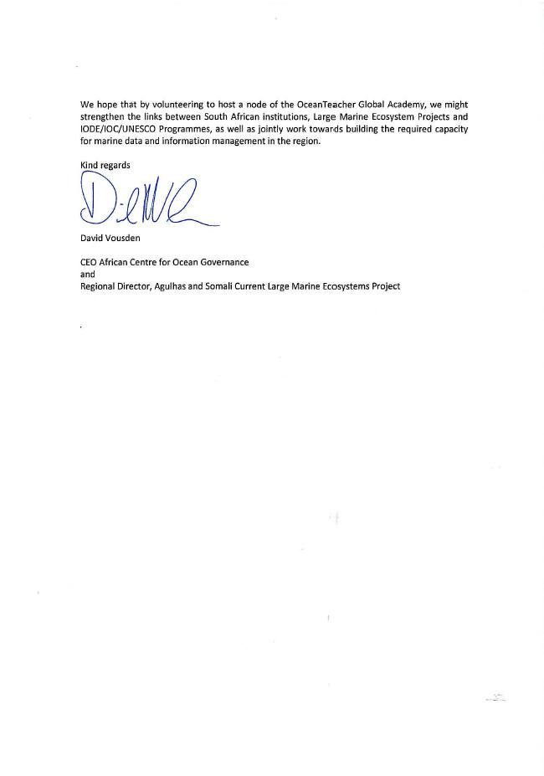

RTC Candidate 4: Comision Permanente des Pacifico Sur (CPPS)
Av. Carlos Julio Arosemena, Km. 3,
Edificio Classic, 2º piso
Guayaquil, Ecuador
Contact: Fernando Felix, Project Coordinator
Email: sgeneral@cpps-int.org or ffelix@cpps-int.org

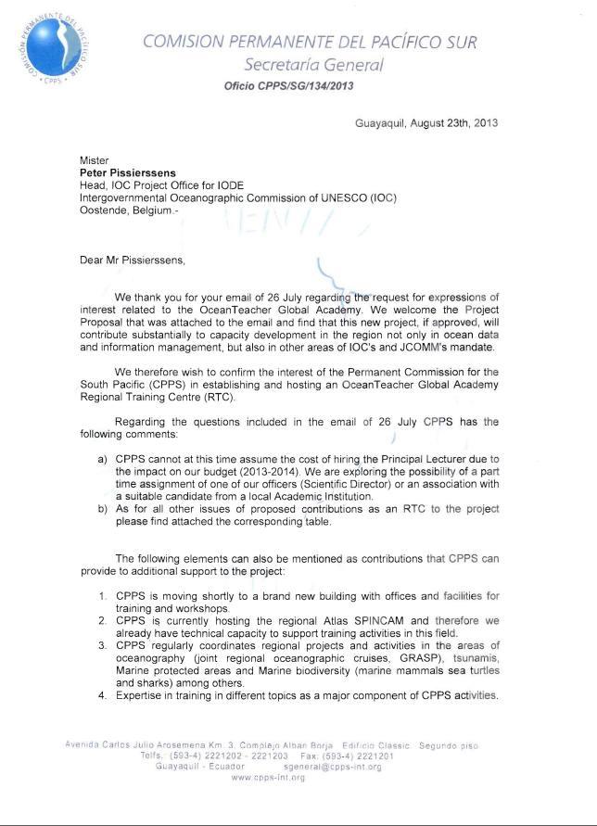

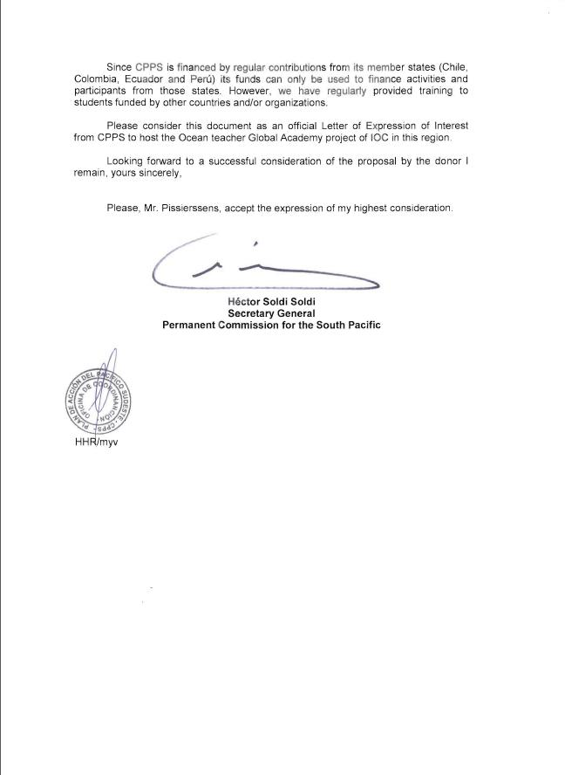

RTC Candidate 5: Universidade Eduardo Mondlane
Escola Superior de Ciencias Marinhas e Costeiras
Maputo – MOZAMBIQUE
Contact: Prof. Antionio Mubango Hoguane
Associate Professor of Physical Oceanography and Head of the School
Email: hoguane@yahoo.com.br

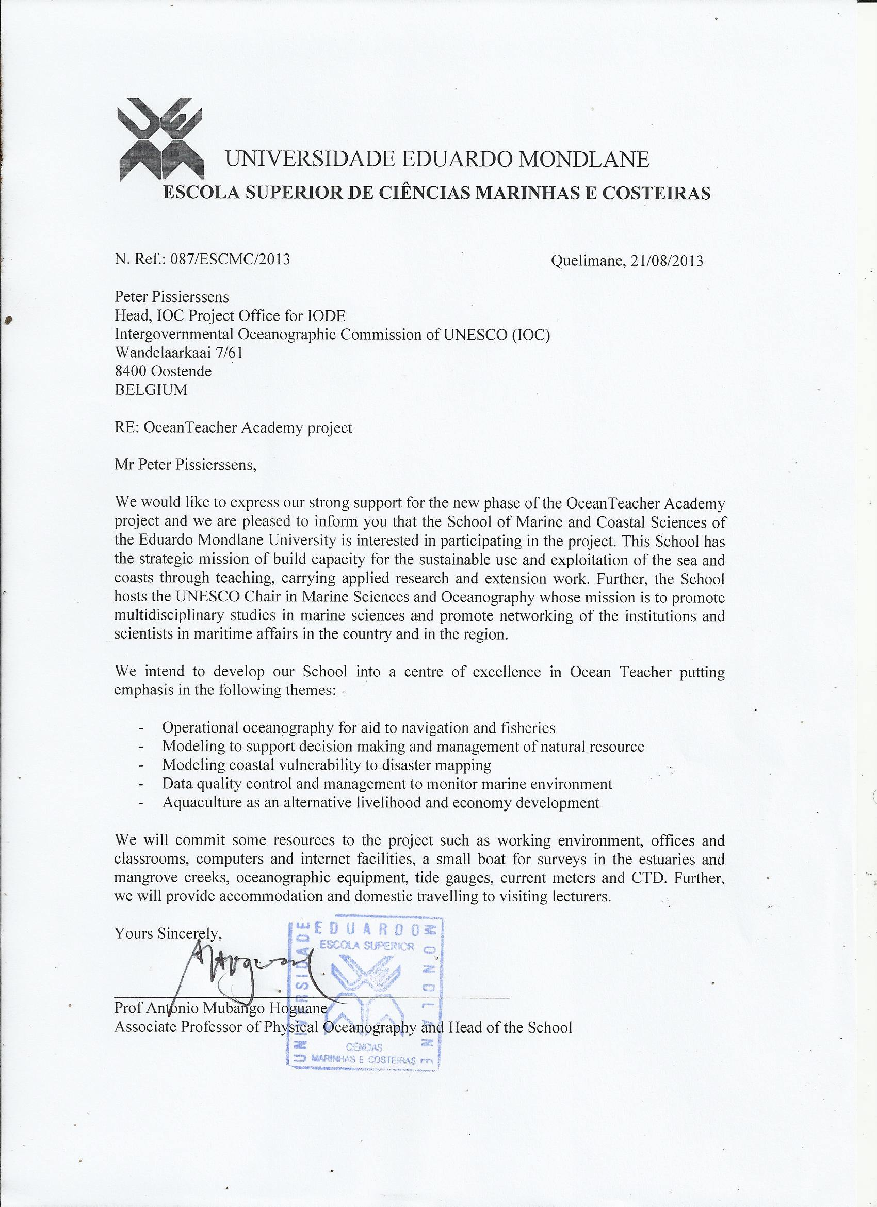

RTC Candidate 6: Instituto de Investigaciones Marinas y Costeras “Jose Benito Vives de Andreis”
Santa Marta
Colombia
Contact: Dr Francisco A. Arias-Isaza, General Director INVEMAR
Email: francisco.arias@invemar.org.co

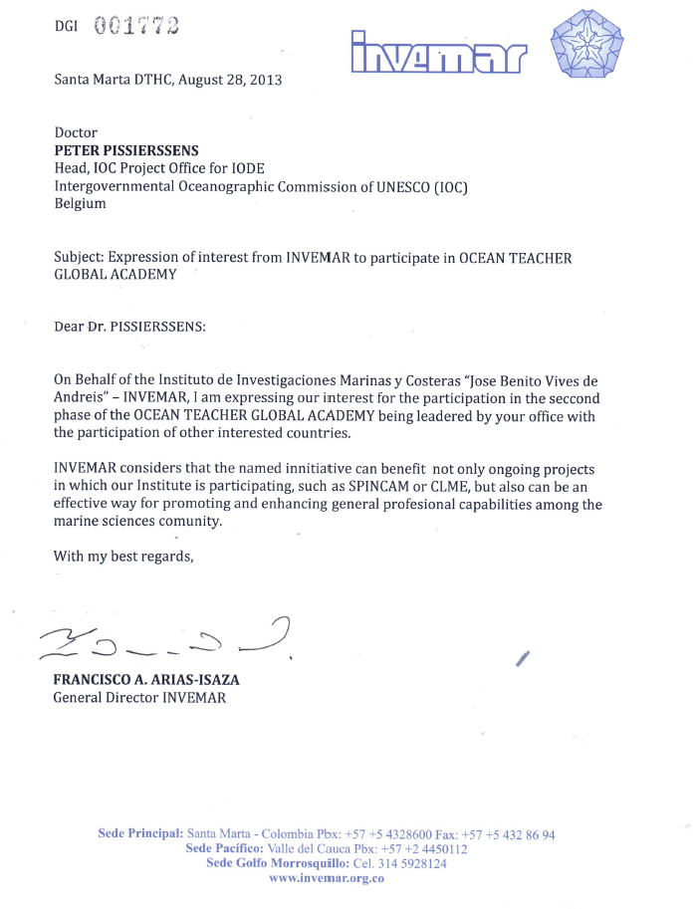

RTC Candidate 7: Kenya Marine and Fisheries Research Institute (KMFRI)
PO Box 81651
Mombasa, Kenya
Contact: Dr Johnson Kazungu, Director
Email: director@kmfri.co.ke

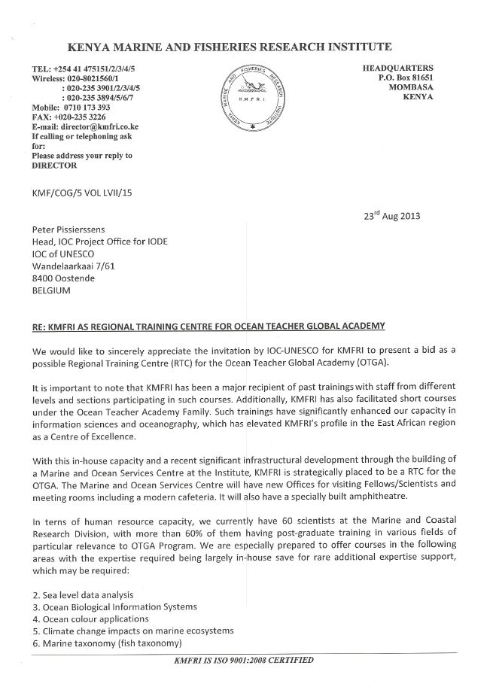

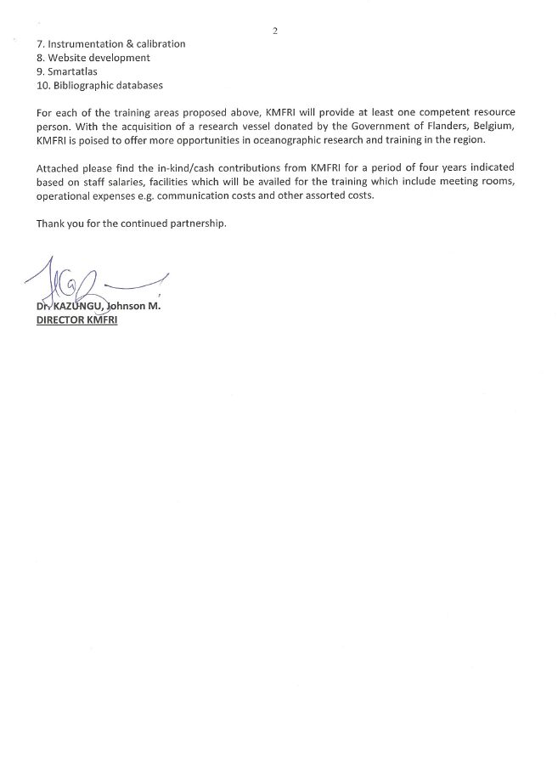
RTC Candidate 8: Institut Sénégalais de recherches agricoles (ISRA)
Centre de recherches océanographiques de Dakar-Thiaroye (CRODT)
Boite Postale 2241
Dakar, Senegal
Contact: Dr Hamet Diaw Diadhiou, Directeur
Email: hamet_diadhiou@yahoo.fr

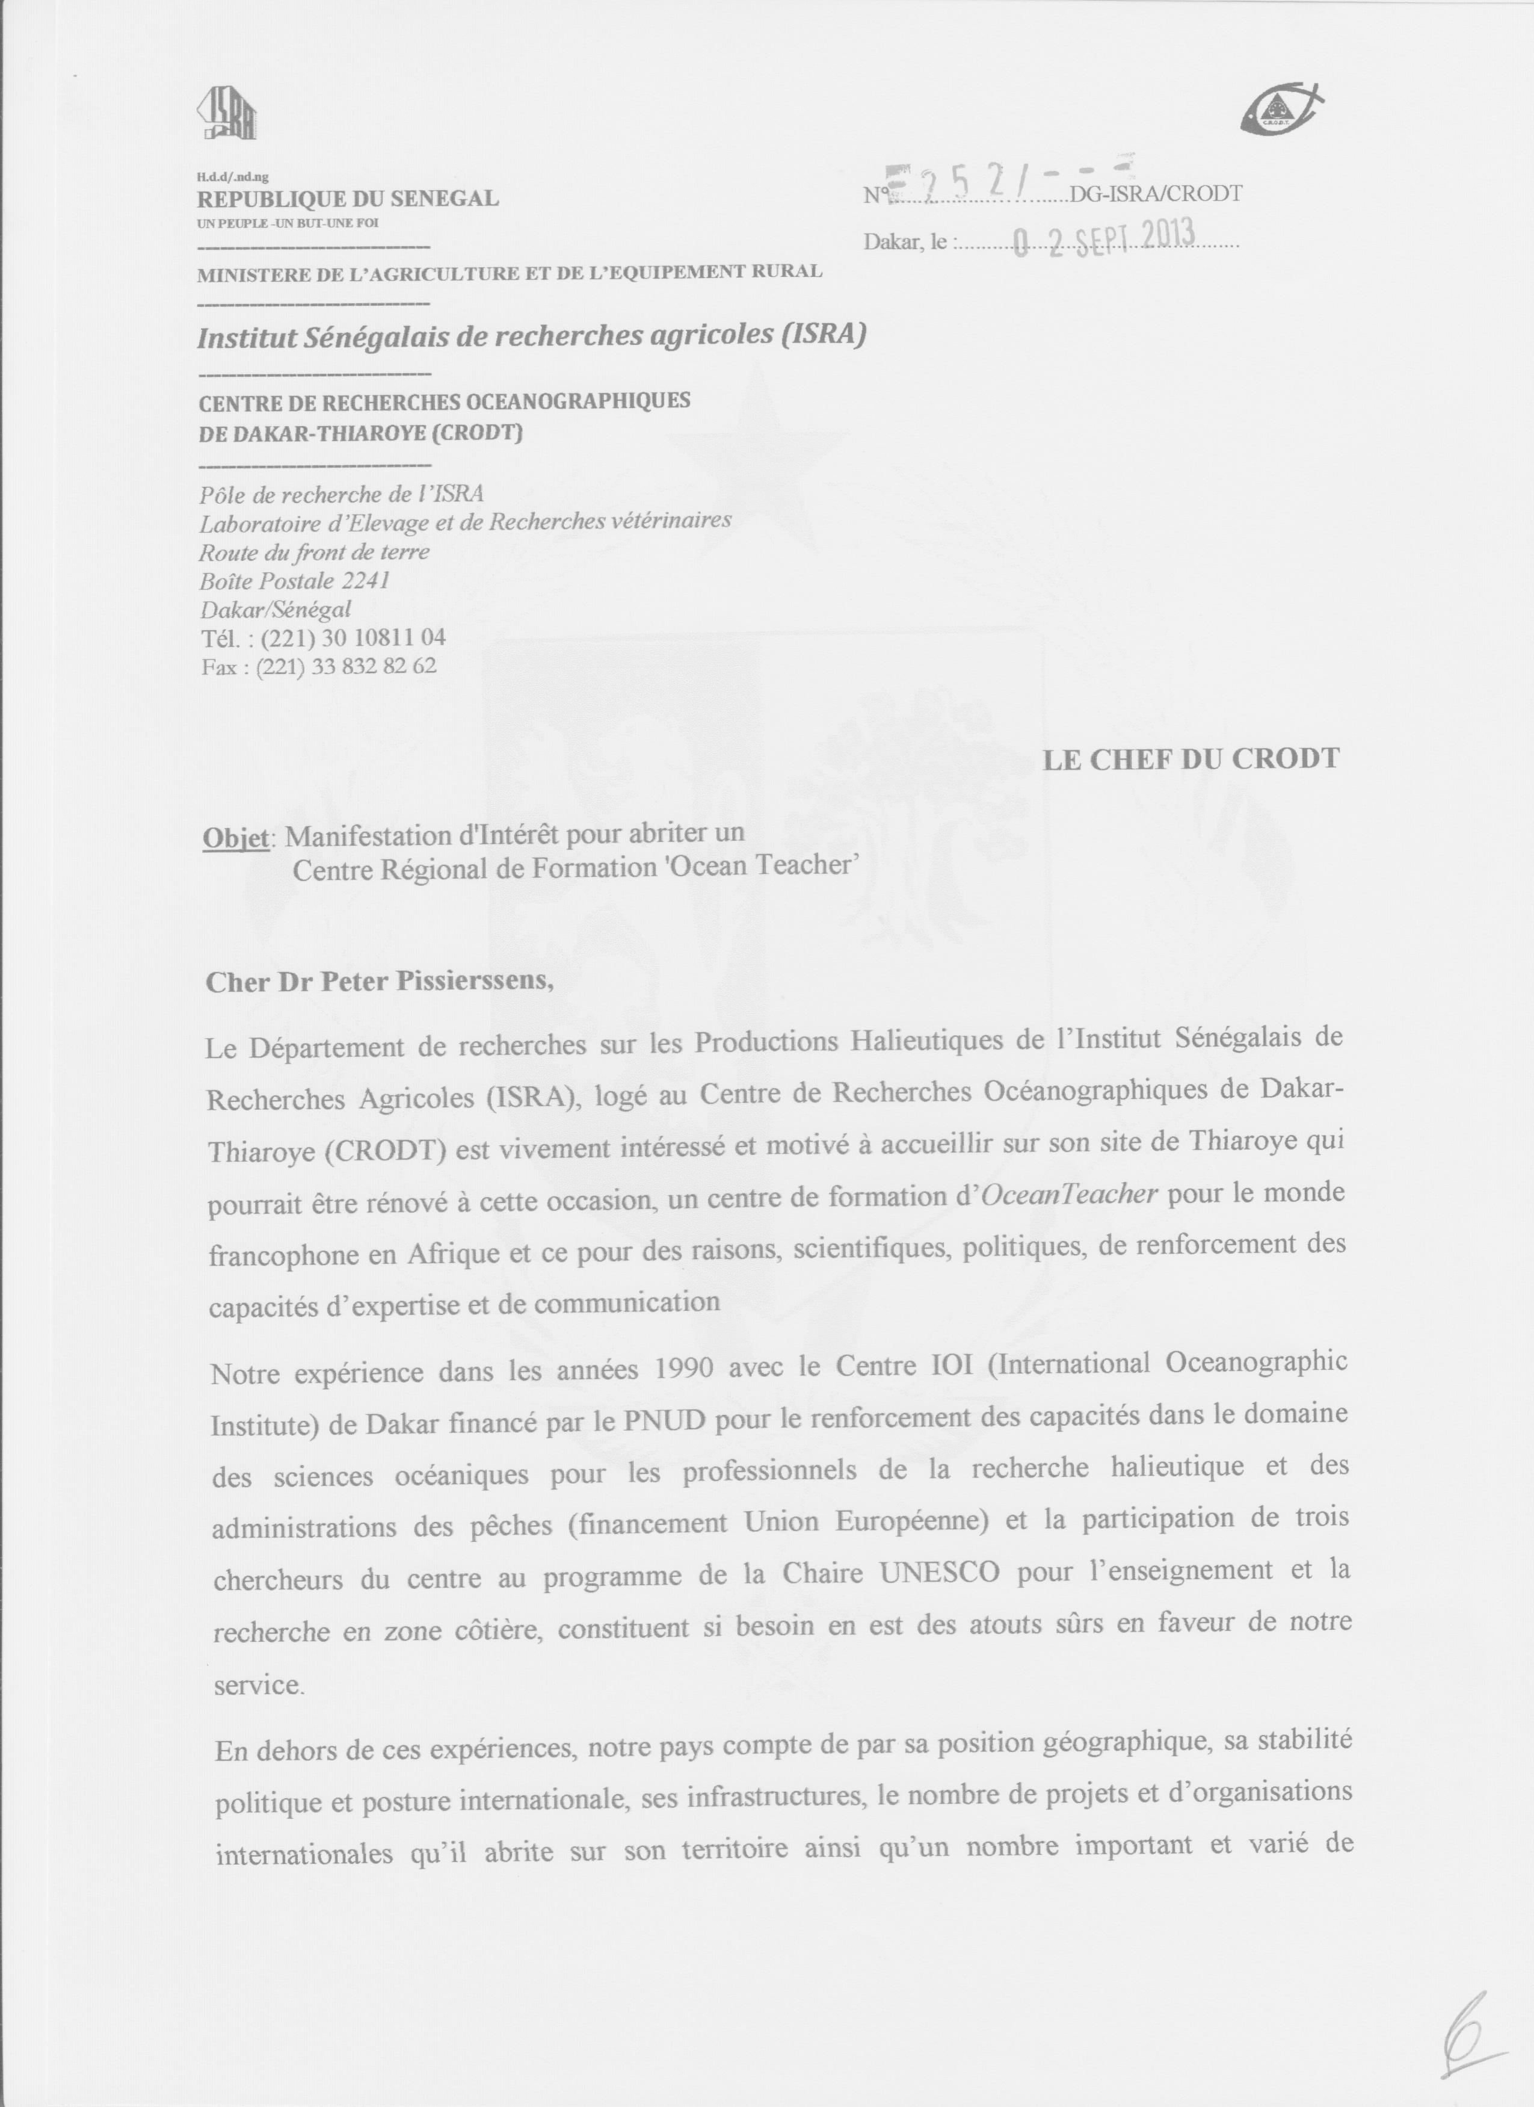
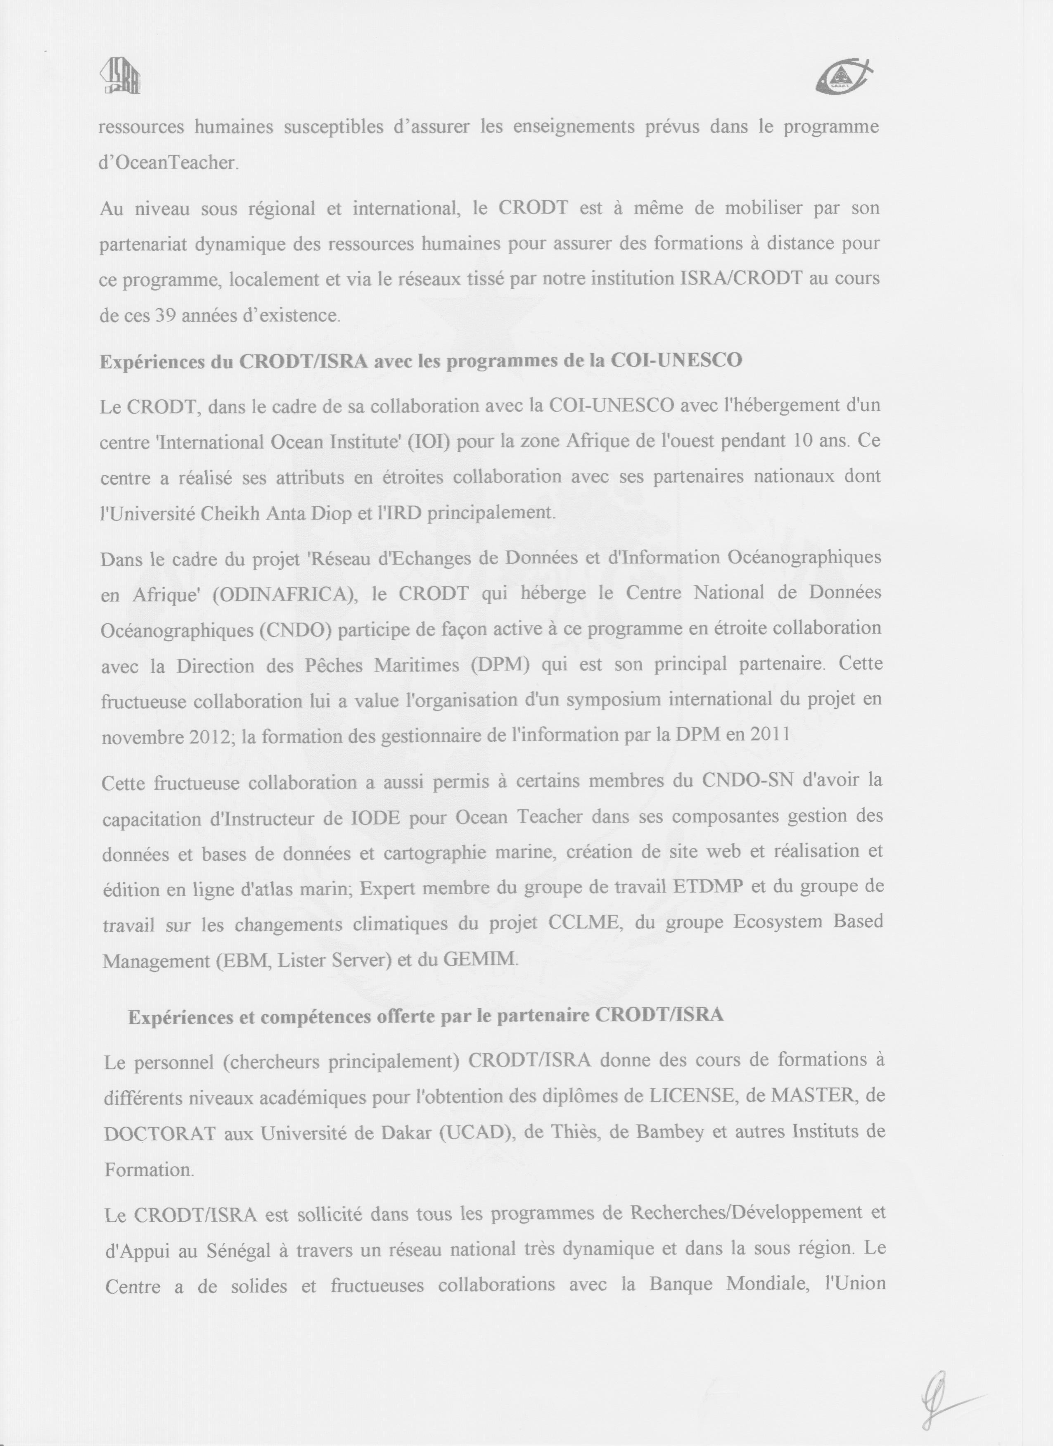
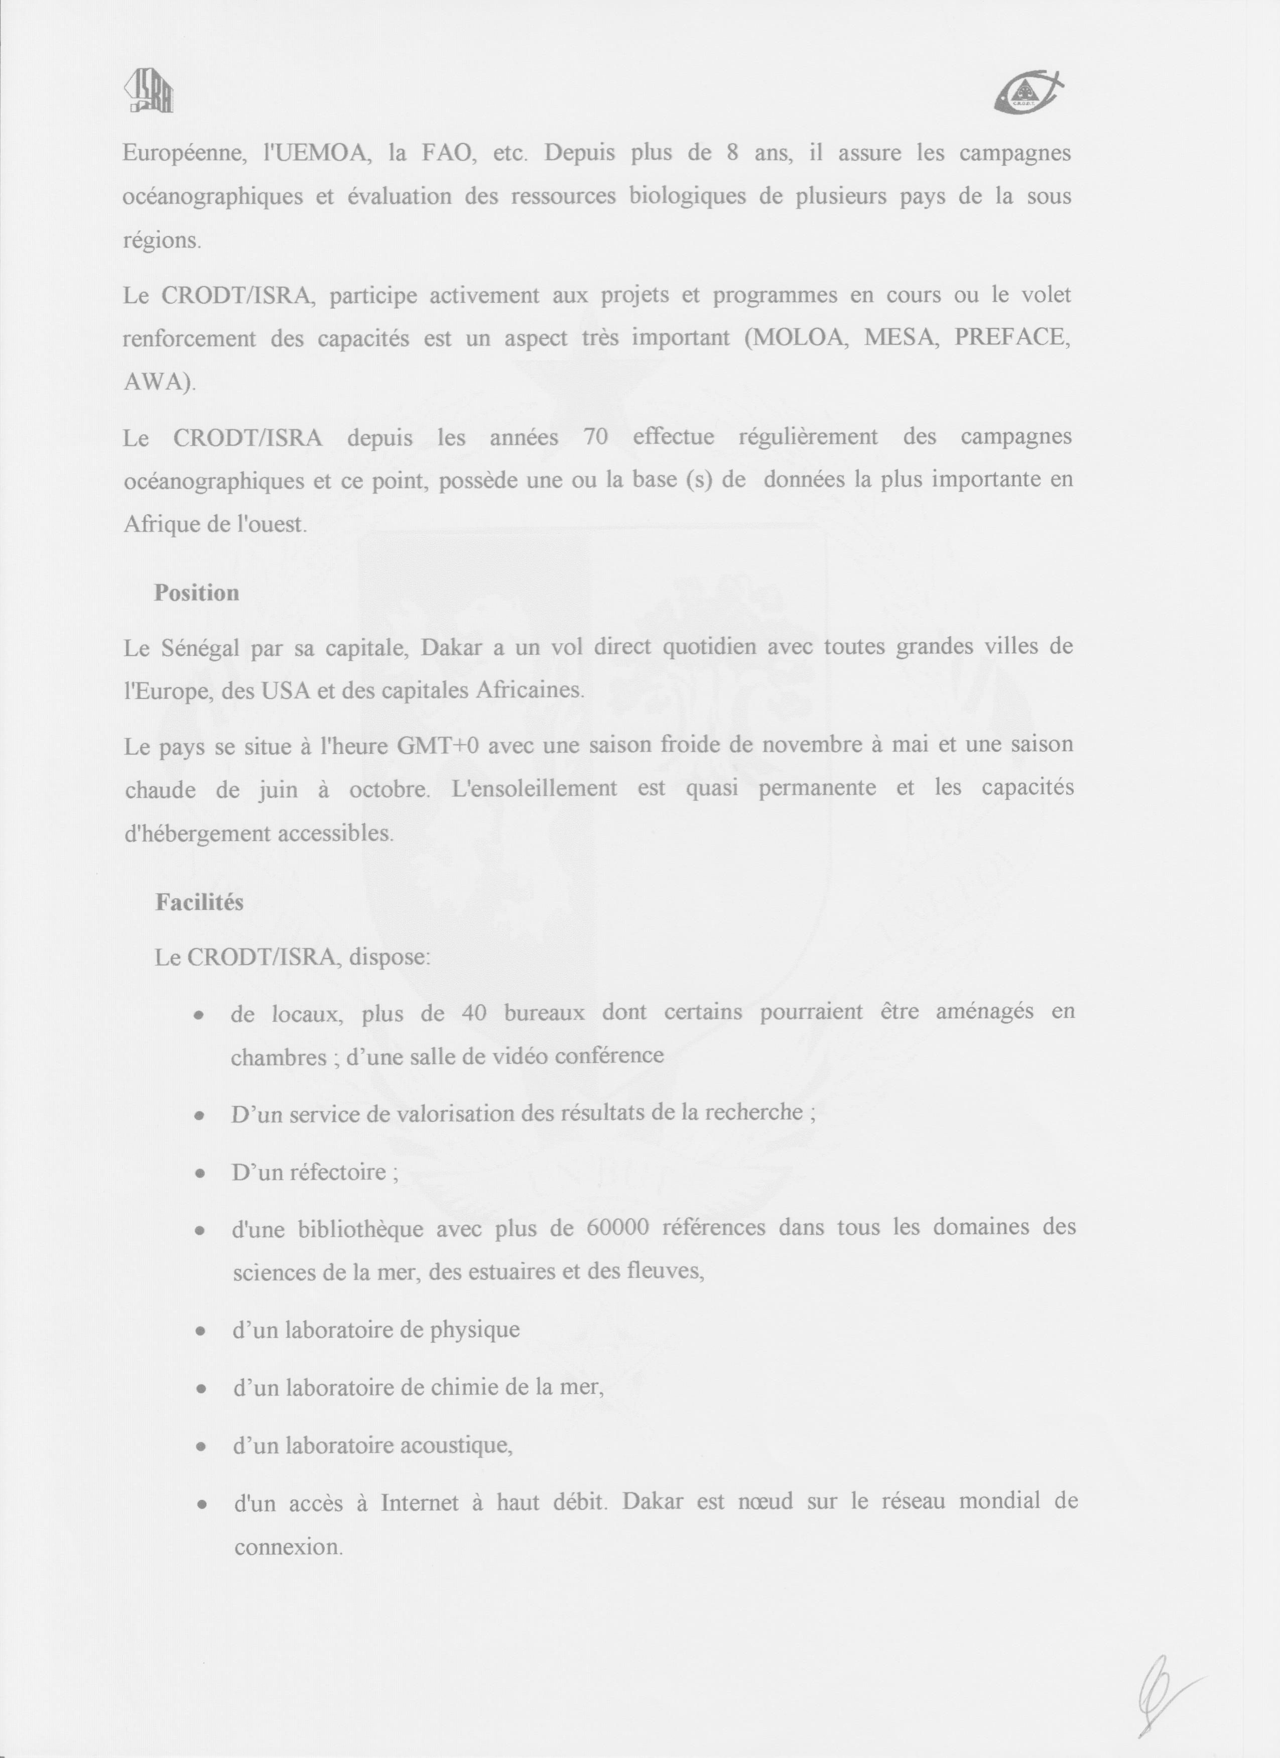
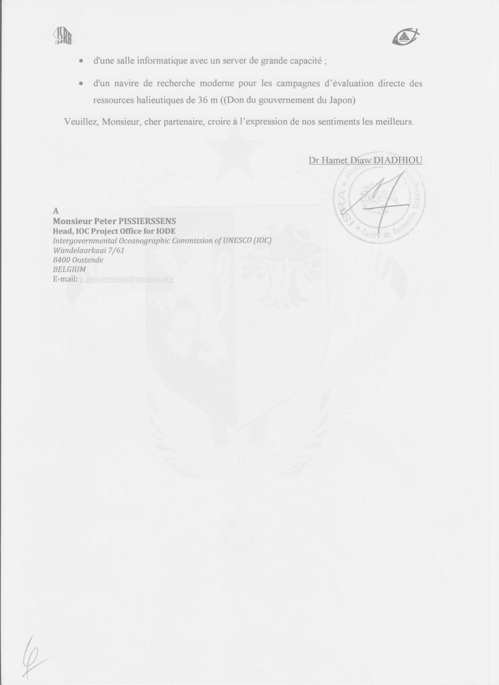
Note: the following candidates expressed interest but were not able to submit the required documentation by 2 September 2013. It is recommended that these candidates are given the opportunity to submit later (and be assessed together with the 8 above).

RTC Candidate 9: NMDIS, Tinajin, China
RTC Candidate 10: Argentina

Part 2: IOC programmes/sections

The following IOC Programmes have expressed interest in participatin in the OceanTeacher Global Academy:

- Tsunami (TSU):
Contacts: Thorkild Aarup (t.aarup@unesco.org) , Bernardo Aliaga (b.aliaga@unesco.org), Tony Elliott (t.elliott@unesco.org)
The Caribbean Tsunami Information Center (CTIC) was established in 2013 by MoU between the Department of Emergency Management (DEM) of Barbados and UNESCO/IOC, attached FYI. Due to its primary role on training and capacity building for the Caribbean region, CTIC seems to be a pertinent partner for the OTGA project and for a potential RTC within the Caribbean region. We are supporting training activities run by CTIC in 2013-2014 with UNESCO funding.
We envisage CTIC running regular trainings on tsunami Standard Operating procedures (SOP) and tsunami Public Awareness and Education (PAE). While at this stage I can’t confirm the funding source I assume that we will have funding to support those trainings (one week each, 2 in Year 1 and 2 in Year 3) for 2014 and 2016. Perhaps one of the trainings in 2014 (assuming OTGA start in April) may qualify as effective counterpart for the project from the currently signed IPA. (possible counterpart contribution approx.. 60K$)

- Ocean Science (ICAM/MSP, WOA)
Contact: Julian Barbière (j.barbiere@unesco.org)

- Ocean Science (HAB)
Contact: Henrik Enevoldsen (h.enevoldsen@bio.ku.dk)

- Global Ocean Observing System (GOOS) and JCOMM
Contact: Albert Fischer (a.fischer@unesco.org)

- IOC Sub Commission for Africa and the Adjacent Island States (IOCAFRICA)
Contact: Mika Odido (m.odido@unesco.org)

- IOC Sub-Commission for the Caribbean and Adjacent Regions (IOCARIBE)
Contact: Mr Cesar Toro (c.toro@unesco.org)

- IOC Sub-Commission for the Western Pacific (WESTPAC)
Contact: Mr Wenxi Zhu (w.zhu@unesco.org)

- IOC Capacity development
Contact: Mr Mitrasen Bhikajee (m.bhikajee@unesco.org)

[end of document]

